README: Grazioso Salvare Rescue Animal Dashboard
1. Required Functionality
The purpose of this project is to provide Grazioso Salvare with a functional, interactive web dashboard to help identify suitable canine candidates for search-and-rescue training. The dashboard interfaces with a MongoDB database containing animal shelter data and allows users to filter, visualize, and explore this data in real-time.
The key functionalities of the dashboard are:
- Interactive Filtering: Users can filter the animal data based on three specific search-and-rescue profiles using radio buttons:
  - Water Rescue: Filters for intact females of specific water-proficient breeds under two years of age.
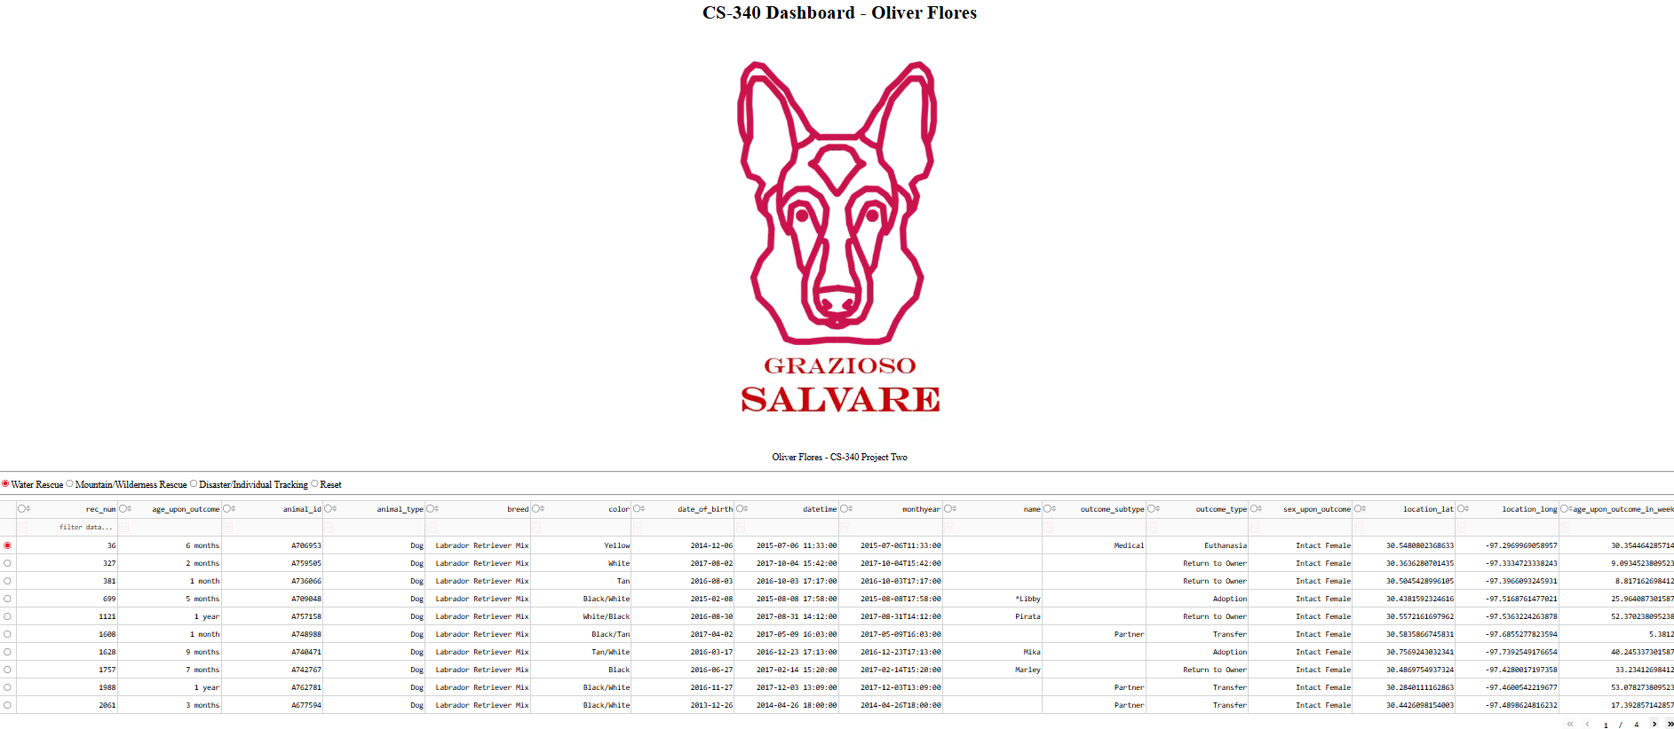
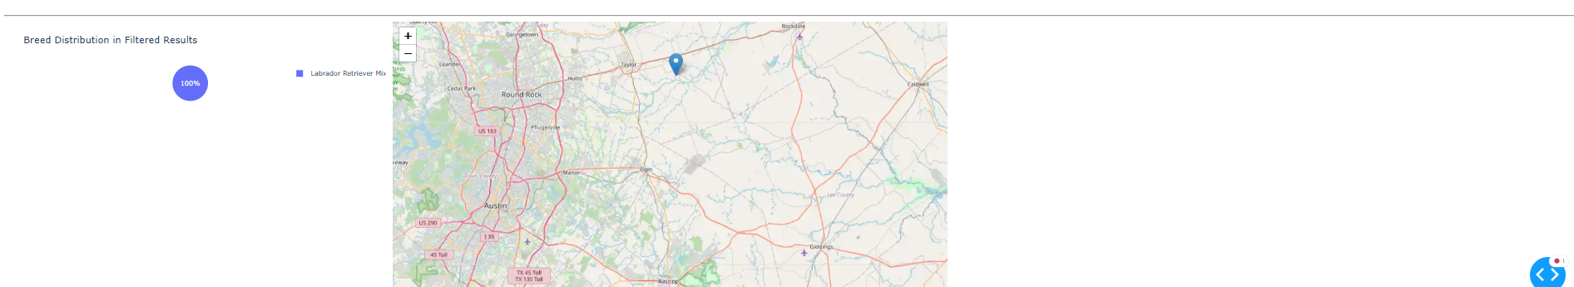
  - Mountain/Wilderness Rescue: Filters for intact males of specific mountain-proficient breeds under two years of age.
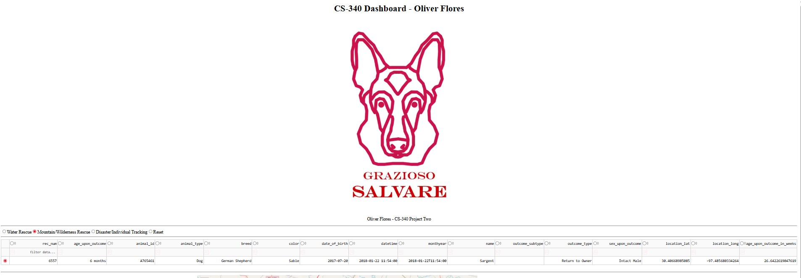
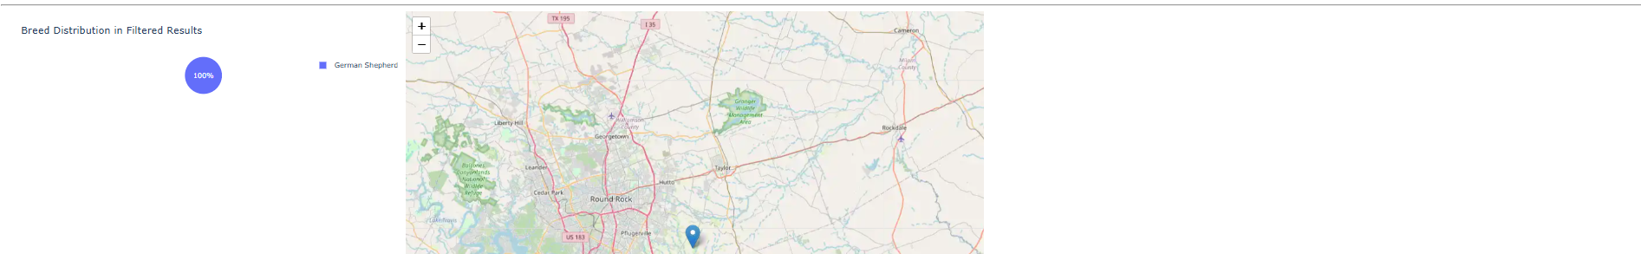
  - Disaster/Individual Tracking: Filters for intact males of specific tracking-proficient breeds under two years of age.
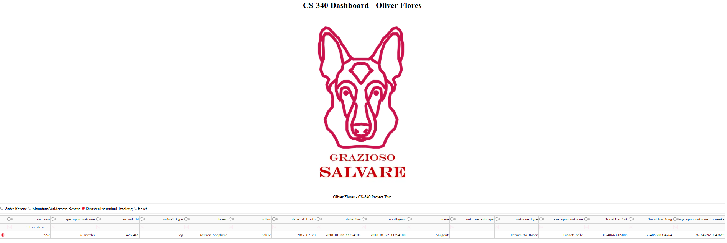
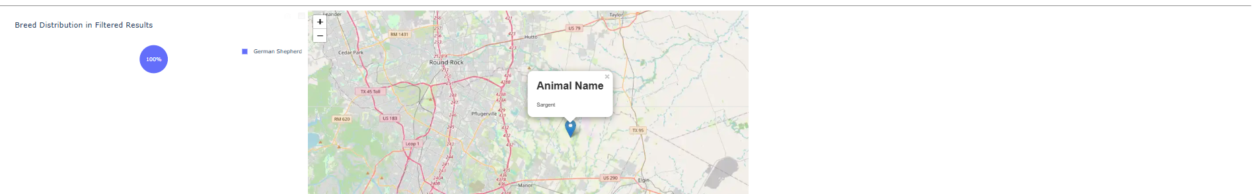

  - Reset: A button is provided to clear all filters and view all animals in the database.
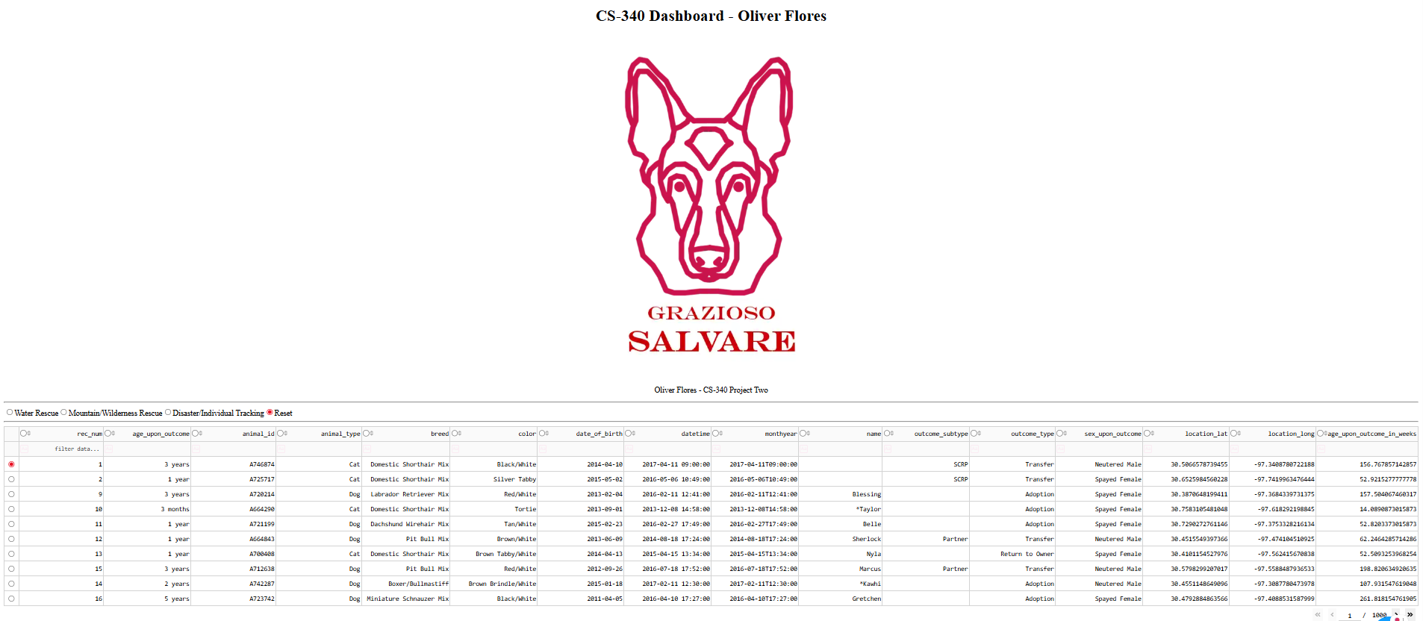
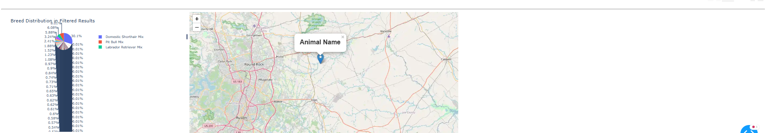
- Dynamic Data Table: An interactive table displays the animals that match the current filter criteria. This table supports native sorting, filtering by column, and pagination to handle large datasets gracefully.
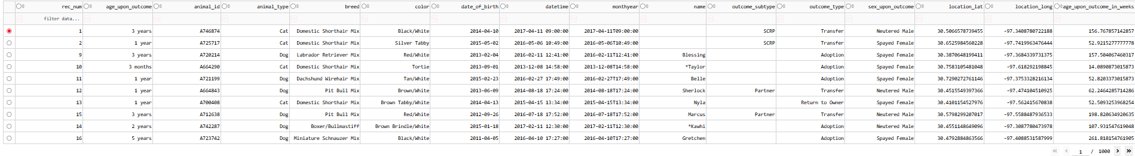
- Data Visualization Chart: A pie chart is displayed alongside the map, showing the proportional distribution of breeds for the animals currently visible in the data table. This chart updates automatically as the user applies different filters.
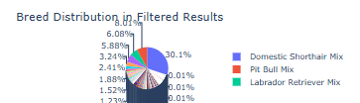
- Geolocation Mapping: A map displays the location of a selected animal. When a user clicks on a row in the data table, a marker appears on the map at the animal's grid coordinates, with a tooltip showing its breed and a popup showing its name.
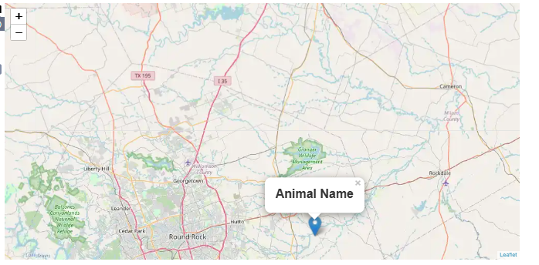
Dashboard Demonstration
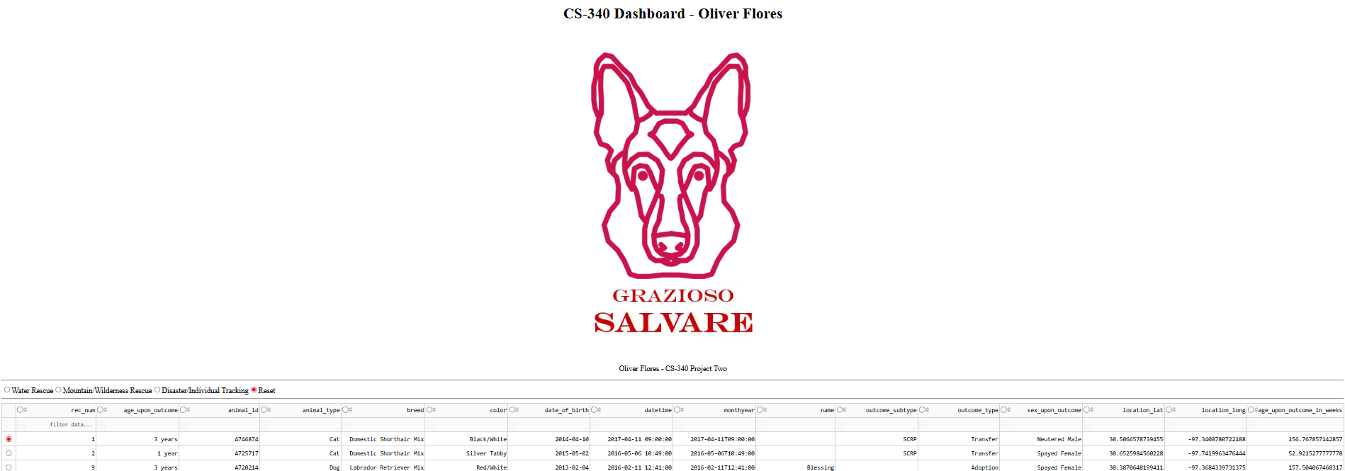
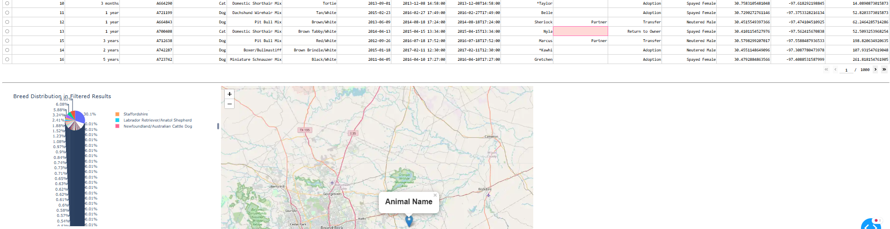
2. Tools and Rationale
This project was built using a modern Python-based web stack, chosen for its efficiency, powerful data handling capabilities, and robust visualization options.
- MongoDB (The Model Component)
MongoDB was selected as the database (the "Model") for this project due to its nature as a NoSQL, document-oriented database. This is ideal for the project scenario for several reasons:
  - Flexibility: The data comes from various animal shelters, which may have slightly different data formats. MongoDB's schema-less design easily accommodates these variations without requiring a rigid, predefined table structure.
  - Rich Query Language: MongoDB's query language is extremely powerful, allowing for complex queries directly within the code. This was essential for implementing the compound filters (e.g., age, sex, and breed all in one query) required by Grazioso Salvare.
  - Python Integration: MongoDB's official Python driver, PyMongo, provides a simple and intuitive API for connecting to and interacting with the database. It allows developers to work with database documents as if they were native Python dictionaries, which simplifies the development process significantly.
- Dash Framework (The View and Controller Components)
The Dash framework was used to build the web application itself, providing both the "View" (the HTML layout) and the "Controller" (the Python callbacks that handle user interaction).
  - Pure Python: Dash allows for the creation of complex, interactive web dashboards using only Python. This eliminates the need for writing separate JavaScript, HTML, and CSS, streamlining the development process.
  - Reactive Callbacks: Dash's core feature is its "callback" system. This allows functions to be automatically triggered by user interactions (like clicking a button or selecting a table row), making it easy to create dynamic and responsive applications. This was used to update the data table, pie chart, and map whenever a user changed the filter.
  - Component Libraries: Dash has a rich ecosystem of component libraries, such as dash_table for interactive tables and dash_leaflet for geolocation maps, which provided the advanced functionality required for this project out-of-the-box.
- Supporting Libraries and Resources
  - Pandas: Used for data manipulation. It provides the DataFrame structure, which is a powerful and efficient way to handle the data read from MongoDB before passing it to the dashboard components.
  - Plotly Express: Used for creating the data visualization (pie chart). It integrates seamlessly with Dash and pandas.
  - JupyterDash: A version of Dash designed to run directly inside a Jupyter Notebook, which was the development environment for this project.
3. Steps to Complete the Project
- Module Enhancement: The existing CRUD_Python_Module was updated. The __init__ method was modified to accept all connection parameters (user, password, host, etc.), and the read method was enhanced to support MongoDB projections.
- Dashboard Layout: The initial HTML layout was constructed in the ProjectTwoDashboard.ipynb file. This included adding the Grazioso Salvare logo, my unique student identifier (Oliver Flores), the dcc.RadioItems component for filtering, the dash_table.DataTable for displaying data, and the Div elements for the chart and map.
- Filtering Logic: The update_dashboard callback was implemented. This function builds and executes a specific MongoDB query based on which radio button is selected and returns the resulting data to update the DataTable.
- Chart Implementation: The update_graphs callback was created. This function takes the filtered data currently visible in the table, uses pandas to group it by breed, and generates a Plotly Express pie chart.
- Map Implementation: The update_map callback was implemented. This function takes the selected row from the data table, extracts the latitude and longitude, and renders a dash_leaflet map with a marker at that location.
- Debugging and Refinement: The application was run, and several errors were identified and fixed, primarily related to data types (TypeError) and empty/initial states (IndexError). Robust "guard clauses" and a try...except block were added to make the application stable and prevent it from crashing during use.
4. Challenges and Resolutions
During the development of this dashboard, a technical challenge was encountered.
- Challenge: Map not being displayed
  - Problem: When running the code, the map was originally not displaying even when clicking the radio buttons to change target.
  - Resolution: I added the selected_rows=[0] property to the dash_table.DataTable component. This action forces the table to pre-select the first row upon loading, providing the map callback with the initial data it needed to render. By resolving the startup error, the dashboard became fully functional, allowing the interactive filters to update the map.
